To most people, the emergence of microelectronics is seen to be a sudden technological breakthrough, but it actually results from continuos research effort extending back to the 1920's. Since the 1950's this research has reduced the cost of a large computer system by about 25% each year. Originally computers were economically sensible only for a limited range of tasks, such as working out repetitive calculations for army weaponry or nautical tables. But continual improvements in their design and a steady drop in their price has allowed them to develop from devices undertaking a few specialists tasks into a powerful and general - purpose technology. When micro-technology was a small industry, the 25% annual increase in performance was not particularly important, but it has an enormous effect now that the industry is worth a hundred billion dollars annually. The technological progress has generally been evolutionary, extending well-known techniques; it is the cumulative results of this steady evolution that are evolutionary.
The most significant and perhaps most disturbing, aspect of the micro-electronics industry is that it is still far from reaching its full potential, and hence the main impact of the technology has yet to be felt. The rate of technological change is so rapid that every piece of electronic equipment currently in production is obsolete. At least ten more years of development can be found in the laboratory, and even the effects of today's technology have not yet worked their way through to the market place. If micro-electronics developed no further, there would still be many years of implementation, delayed by a shortage of skilled people. On the basis of past trends, this decade will see prices fall to one-twentieth of their past level, and computer processors should become several hundred times faster.
The key to the steady development of microelectronics has been the relentless improvement of integrated circuits, or ‘microchips’. A complete electronic circuit can be built on to a small square of silicon. Each individual circuit is only one of many chips being simultaneously formed on one thin disc of silicon ( a wafer ). All component parts of a circuit can be made by a sequence of chemical processes on the wafer surface, involving etching with acids, adding impurities, and evaporating aluminuim. In particular, millions of small electronic switches-transistors-can be made on a wafer.
Each chip which is the size of a child’s finger-nail and may form a complete electronic circuit, could be a radio, computer, or a telephone. Chips are becoming faster, cheaper, more reliable, and more powerful. A single integrated circuit replaces many older chips, as well as circuit boards, plugs, and sockets. Reliability goes up and the consumption of electricity goes down. The initial investment needed to design and perfect such a chip is very large, but the circuits can be replicated at a negligible cost. Wafer processing is a highly complex, but well understood, technology, the cost of which stays the same, regardless of the complexity of chips being made.
In 1964 Gordon Moore, now president of the American company Intel, pointed out that the number of transistors that could be made in a single integrated circuit had doubled every year since the first chip had been produced In 1959. At the time this was not a very spectacular claim, for the number had risen from 1 to about 30 in five years. But ‘Moore’s Law’ is still approximately true, and so integrated circuits with more than ten million transistors can now be built. Few people within the industry doubt that individual chips with tens of millions of transistors will soon be made.
The validity of Moore’s Law has meant that the number of transistors possible on a single chip increases by a factor of a thousand every ten years, and by a million every twenty years. The circuit becomes smaller, and more can be produced on one silicon wafer. Surely there must be a physical limit to this shrinkage. In the unlikely event of Moore’s law holding to the year 2000, there would be as many transistors on a single integrated circuit as are neurones in the human brain ( about 100,000,000,000).

Moore’s Law

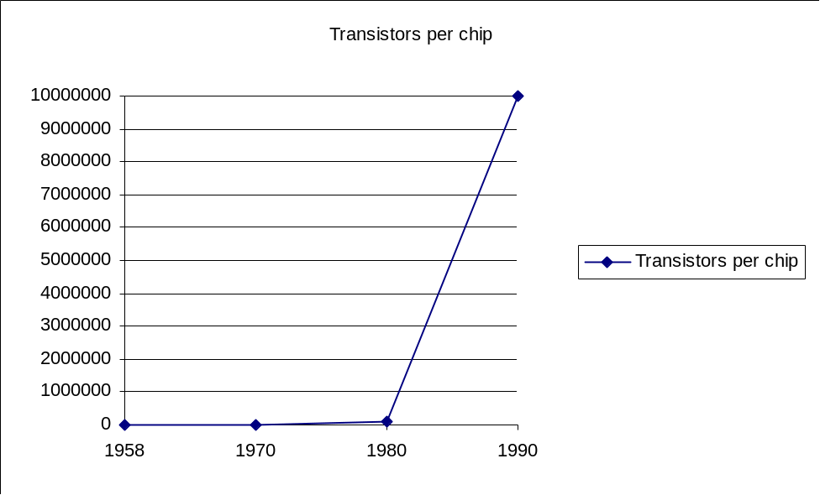

As the number of transistors on a single chip grew, the threshold of complexity was crossed at which a small company could be made. Only a few thousand transistors, correctly connected, are needed to make a useful computer. By the early 1970’s, microelectronics technology had sufficiently advanced for that many transistors to be formed on a single chip, and the whole of the processing section of small computers could be fabricated on a single piece of silicon the micro processor ( often shortened to ‘micro’). Instead of being built for a specific task, the function of this electronic circuit could be changed by altering the computer program controlling the microprocessor. The more transistors that could be built on to the silicon chip, the more powerful the microprocessor could be.
Even the early, primitive microprocessors were comparable in power to the first of the modern day computers, the 100 foot-long ENIAC, built in 1945. Today the processing power costs pennies instead of millions of pounds. Since 1971, the single chip micro processor has become increasingly powerful, first to match the power of small computers (minicomputers) and then that of more powerful (mainframe) machines. As a result, the whole computer systems are rapidly disappearing into a single silicon chip. In retrospect, the simple application of Moore’s Law should have enabled us to predict and prepare for the arrival of the microprocessor.

How the cost of a product declines with mass production

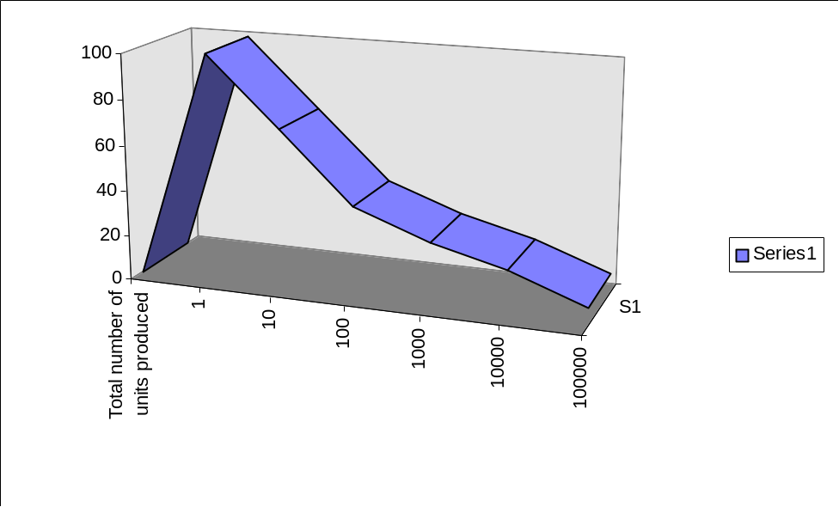

When a product is mass-produced it’s cost in real terms falls steadily. Every time the total number of units which have been produced increases by a factor of ten, the cost approximately declines by 30 per cent. This cost reduction is caused by improved manufacturing experience and increased competition as the market expands. The prices of electronics products seem to conform very well to this ‘experience curve’, which has been found empirically to apply to a whole range of products. The unusual aspect of the micro-technology revolution is the rapidity with which the industry has produced vast numbers of the unit product - the transistor.

The Profits cycle of an electronics product

Over the past thirty years, the electronics industry has experienced unbridled competition. Microtechnology has never been stable enough for companies to form comfortable pricing agreements between themselves. When a new product is developed, the first firm into production has a higher profit for each sale, and therefore tries to increase production as rapidly as possible. Often teething troubles delay mass production. If a market proves lucrative, then other companies soon move in, the production problems are solved, and prices tumble due to their over-capacity. The unit profit declines rapidly, and so the profit rate for the product reaches a peak before the maximum sales are reached. Any firm entering later on in the cycle will make little profit; and for some products such as video games, the cycle may be complete in a year. Meanwhile the leading firm is announcing a more advanced product.

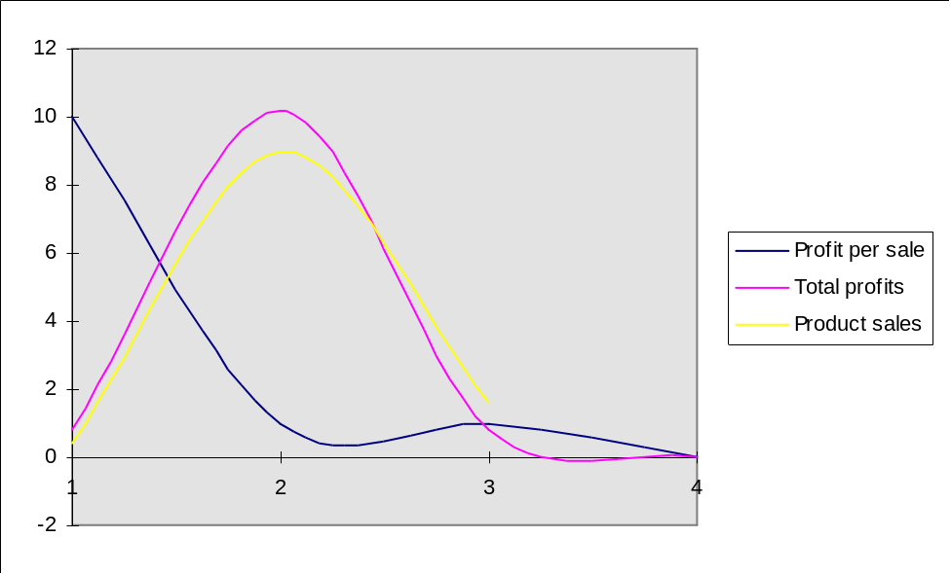

Dividing the growing market for micro electronics

As the overall supply of microelectronics products increases, the European share is being steadily eroded by the USA and Japan. The total value of the basic components consumed by the microelectronics industry world-wide is shown for 1978, 1983 and 1988. The piecharts illustrate how European production of microtechnology is a dwindling proportion of the total.

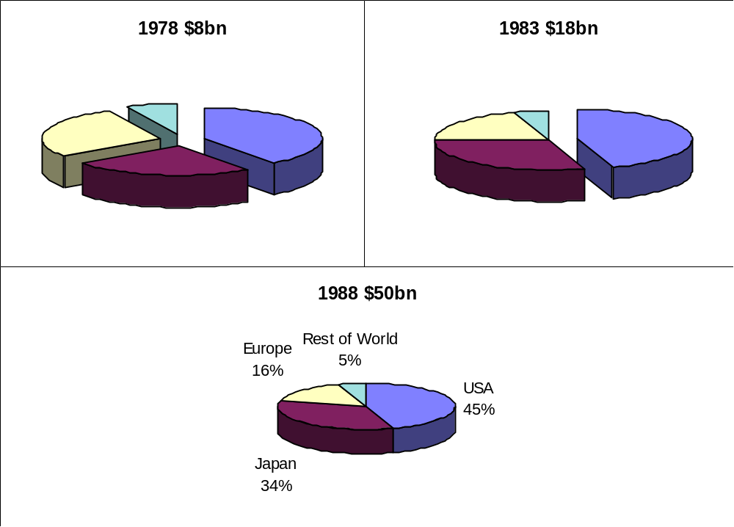

The applications of microcomputer equipment are now primarily limited by our imagination in programming. With more and more powerful computers becoming available, the limitations imposed by the machine itself are falling away, leaving a new challenge to create programs that exploit the technology’s full potential.

The integrated Circuit

Open a computer and you will see rows of black plastic packages, linked together by the solder tracks of a circuit board. Each package contains a single chip, or integrated circuit. Integrated-circuit technology is the key to the microelectronics revolution. The same manufacturing process makes chips that are computers, memories, disc controllers and thousands of other electronic circuits. The many components needed for a circuit, such as a resistor, capacitor and transistor were individually made, and then wired together to make the necessary circuit. Now hundreds of thousands of transistors, a whole circuit and it’s connections, are fabricated on a small piece of silicon.
The process that transforms sand into integrated circuits relies on decades of intensive research, as well as 25 years of applied development. The theory behind semi-conductors was worked out during the 1920’s and 1930’s, and the first transistors were produced at Bell Laboratories in 1947. Since the invention of integrated circuits in 1958, the techniques for producing many transistors on a small semi-conductor chip have been developed enormously. Integrated circuits which sell for a few pence are the result of this research effort and thousands of millions of pounds of investment. At present there seems to be no technological barrier to prevent integrated circuits with 100’s of millions of transistors to be made. The global name for the technology is very large-scale integration (VLSI).

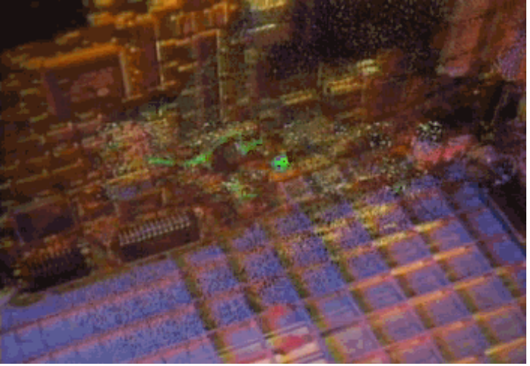

Producing Integrated Circuitry-Summary

The process of producing chips has three stages. In the first, the integrated circuit is designed and perfected using a computer as an intelligent drawing board and notebook. A computer program then simulates the whole circuit to detect possible problems. When the design is satisfactory, the computer makes a set of photographic masks, which control the processing of the chips during the manufacturing stages.
In the second stage, very pure silicon is melted in an enclosed container, and a large crystal is grown from the from the liquid. This is sliced into thin wafers, which are then polished flat and smooth.
The last stage takes place in the silicon foundry, where the thin wafers of silicon are turned into chips through a series of chemical processes. Millions of transistors are formed simultaneously on the surface of each wafer, in patterns controlled by masks. The manufactured chips are tested while they are on the wafer, which is then split up into individual circuit chips. The successful circuits are packaged for sale.
Dozens of electronic circuits are formed when a wafer is processed, and each chip is able to perform the same function as the original computer simulation, but far faster. The sequence of steps to produce a chip is roughly the same for all different kinds of chip, and also for an equivalent chip design with smaller transistors. A small factory employing a hundred or so people can turn out several million integrated circuits every year.

Memory

Semiconductors

Semiconductors such as Silicon, germanium, or gallium arsenide, are substances which have electrical properties between those of metals and insulators. Electrons are the usual means by which electrical current in materials can flow, and in metals, for instance, the negatively charged electrons are free enough to move easily past metal atoms when an electrical voltage is applied to the material-resulting in an electrical current. In an insulator on the other hand, the electrons are held tightly by there atoms and cannot move under the influence of a voltage. Consequently, while metals conduct electricity well, insulators donot allow electricity to flow. As their name implies, semiconductors lie between these two extremes. In a very pure semiconductor crystal, such as silicon, electrons are held rather more weakly than insulators, but still strongly enough to prevent the flow of electricity. Transistors rely on the properties of crystalline semiconductors, and particularly on the ease with which the electrical conduction properties can be locally modified by small amounts of impurities.
In silicon, we are fortunate to have a semiconductor possessing an almost ideal combination of properties necessary for making an integrated circuit. To begin with the sand is largely composed of silicon dioxide, and so silicon is plentiful and cheap. Silicon can be grown into large, almost perfect crystals, and is more resistant to high temperature produced in chips by current flows than other semiconductors, especially compared with germanium, from which the early transistors were made. Heating silicon in the presence of oxygen converts a thin surface layer into silicon dioxide, making a superb insulating material needed for several of a chip’s processing stages. Integrated circuits, such as memory chips or microprocessors, use silicon’s properties to the full.

Producing the Integrated Circuit

Any one dust particle falling onto the silicon wafer could prevent a small area of it’s surface being correctly processed, and cause a complete circuit to fail, for example by breaking a connection between two transistors. Therefore circuits are made in clean rooms, the inner sanctums are integrated - circuit manufacturer. Special attention is made in removing particles of dirt from the air. In an averagely dust-free room there are thousands of millions of such particles floating in the air. The problem dust particles are about 1 - 10 microns in diameter- about two to twenty times thinner than a human hair. Any dust particles larger than these tend to fall to the floor, where they can be easily dealt with. Obviously all surfaces in the clean room have to be kept meticulously clean, but this is a fairly easy task since very little dust actually enters the room.
Sophisticated techniques for removing dust particles from the air have been developed by the semiconductor industry over the last thirty years, and it is surprising that they have not become standard in hospital operating theatres. In the latest design of clean rooms, the roof is turned into a large dust extraction filter, and air is forced down through it under pressure, and out through the floor of the room. The continuous flow of air streaming downwards clears any dust generated by the work within the room. The filter reduces the level of dust by about a factor of a million, perhaps leaving only ten to one hundred particles floating in each cubic foot of air. The air pressure in the room is also kept slightly above that of the outside world, so that if there are any small leaks in the room, or if a door is opened, dirty air is not brought in from the outside world. Entry is through a room with a double-door airlock, where staff change into special clothes. The factory itself is normally situated in a location that is remote from the industrial pollution, in order to reduce the amount of pollutants and grit brought into the room on clothes, in water, or by air leaks.
People are the major cause of contamination within clean rooms. Thus everyone working inside them has to wear a face mask, and is clad from head to toe in clothing which does not shed dust. In the future the fabrication stages will become far more automated, with very few human operators. However, total robotic control is hard to imagine, because so much of the circuit manufacturing equipment is delicate, complicated, and needs continuous maintenance to be kept in good condition.

